Practical CS5052

Movie Recommender System

I have implemented all three parts and this report will summarize my effort.

# Summary Part 1:

In part 1, I have implemented search by user id, search by movie ID or title and search by genre.

For user Id search I have given 7 options,

1. Show titles: shows the titles of the user ID entered.
2. Movies Watched: shows the number of distinct movies watched by a user.
3. Genres Watched: shows the number of genres watched by the user.
4. Genre ratings: shows the average ratings of genres, given by the user.
5. Genre watch count shows the number of movies from each genre watched by the user.
6. Favourite genre based on rating: This gives the favourite genre of the user based on his rating.
7. Favourite genre based on watch count: This gives the favourite genre of the user based on his watch count.

For movie ID and movie name search, I have given 2 options:

1. Watch count: gives the number of times the movie was watched.
2. Rating: gives the average rating of the movie, given by the users.

To give the program user the right movie, I have added the data that matches the letters entered e.g if someone enters “men” or “Men” or any such combination, he will get a list of movies that start with the letters “MEN”.

For Genre search, I have given the option to see all the movies of that genre. Again, I have given the added ability to search if one enters “rom”, he will get romance movies.

I have added the Year search, which gives all the movies from that year.

Lastly for part 1, I have added Top N rated and Top N watched movies, which gives out ‘n’, number entered by user, highest rated or most watched movies.

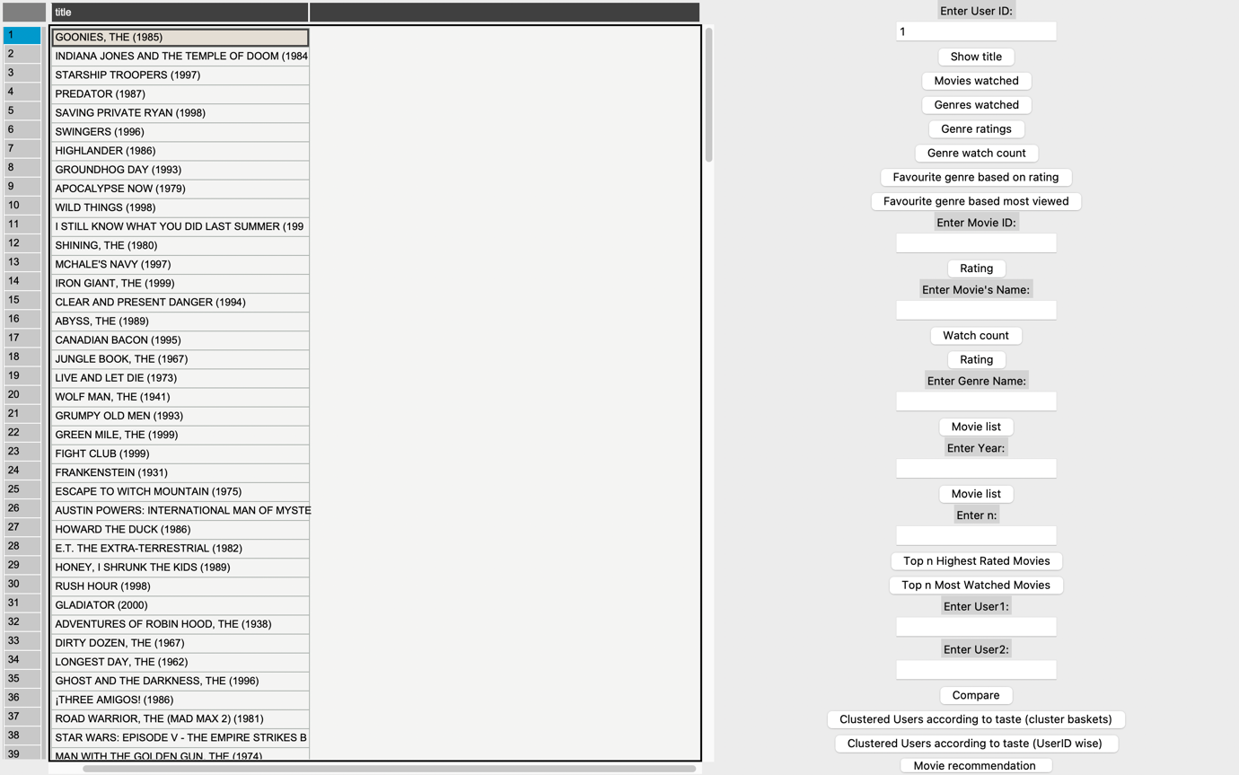

Figure user id title list search

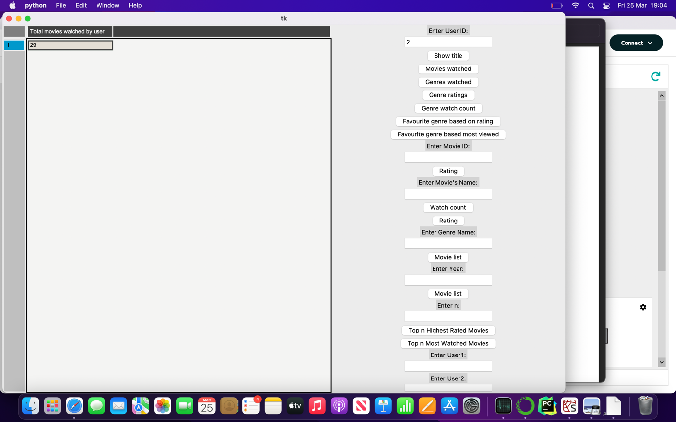

Figure user id total movies watched count

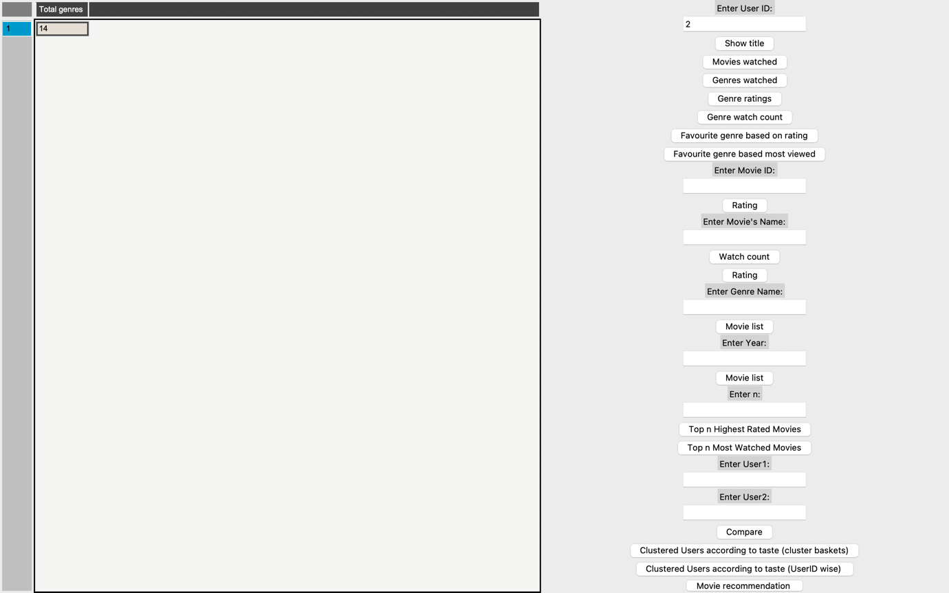

Figure user id total genres watched

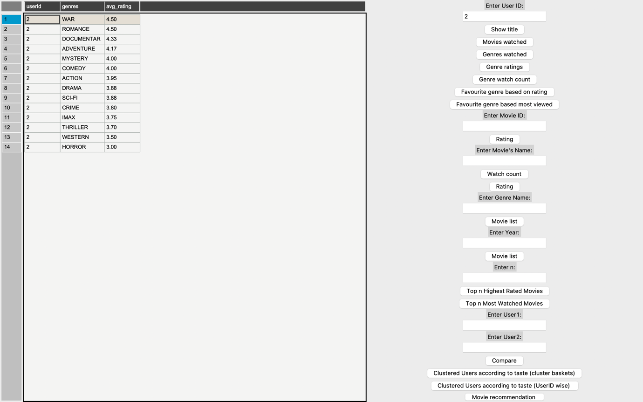

Figure user id genre list sorted by highest ratings

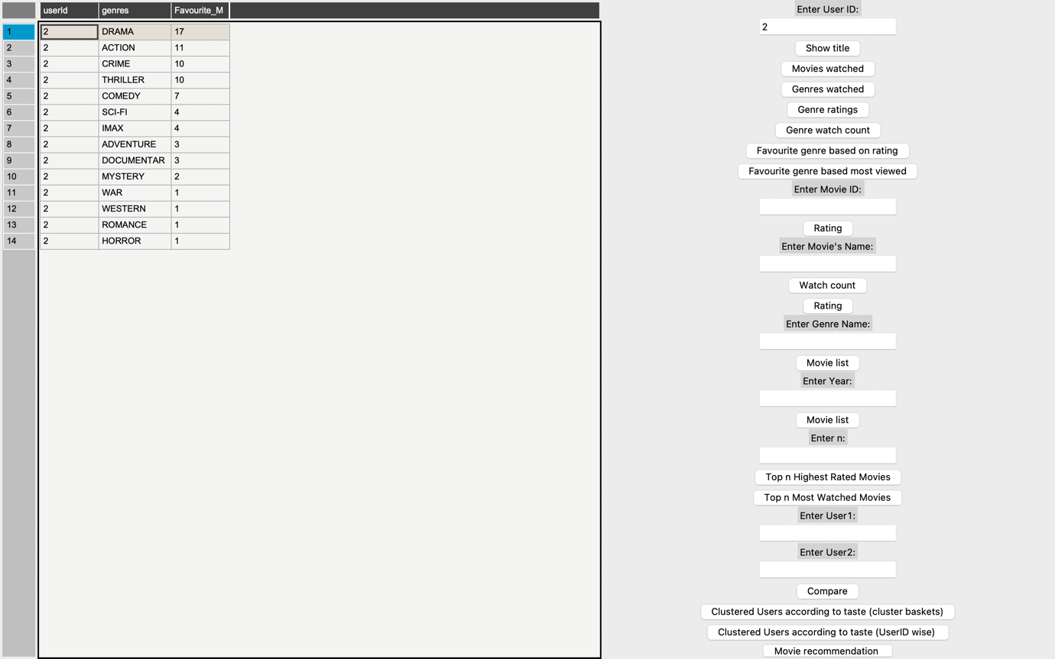

Figure user id genre list sorted by most watched

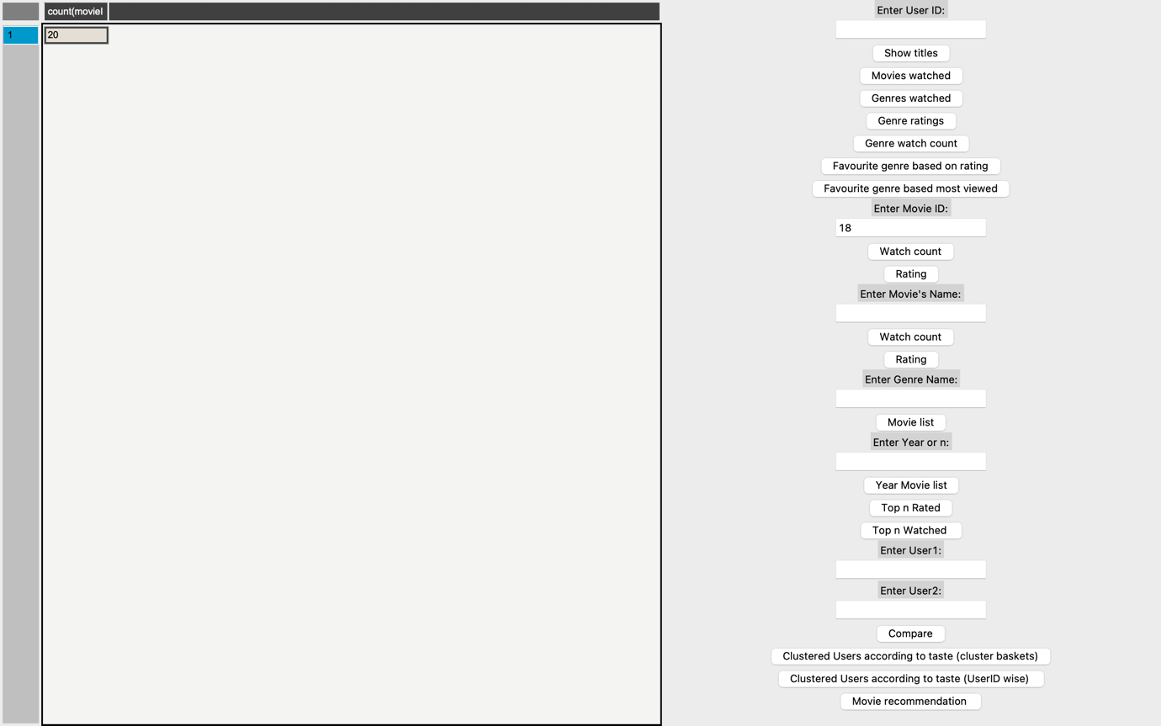

Figure movie ID watch count

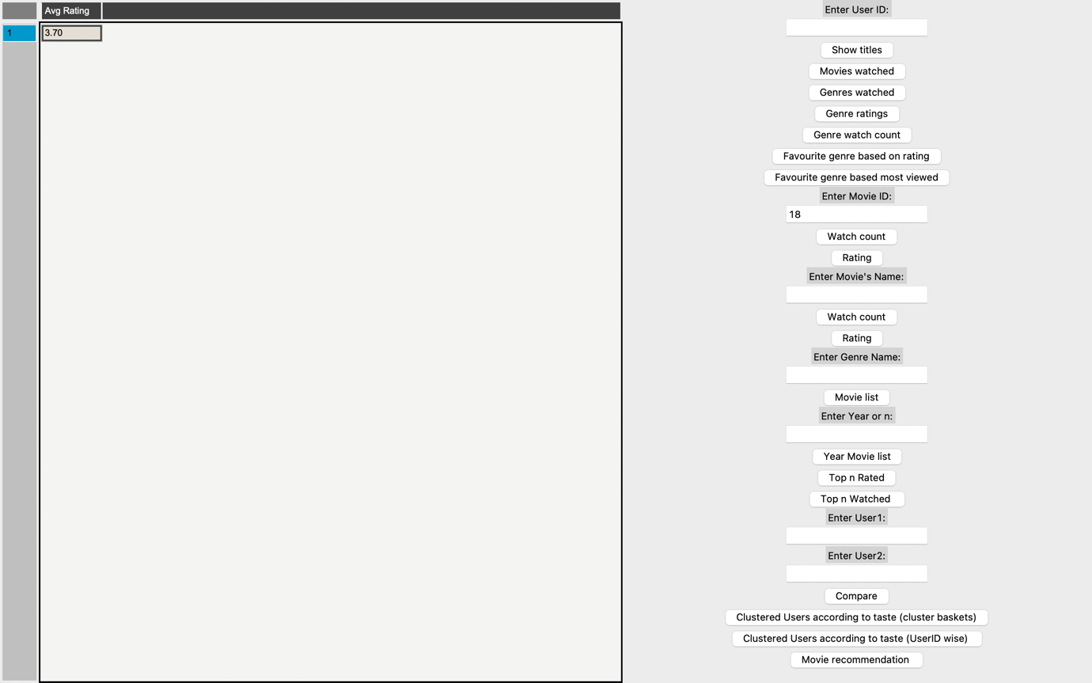

Figure movie Id rating

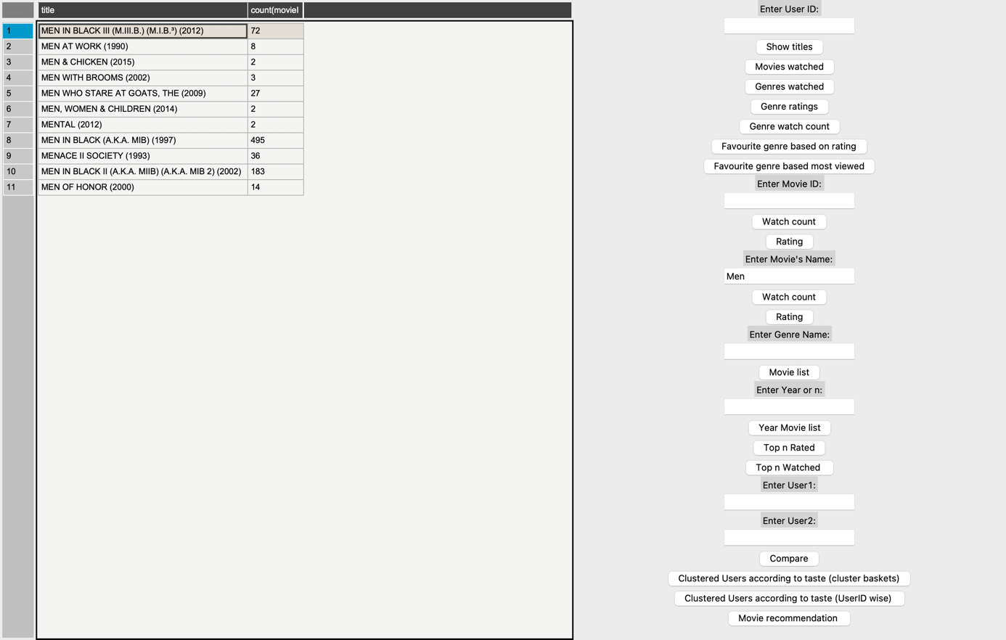

Figure movie name watch count

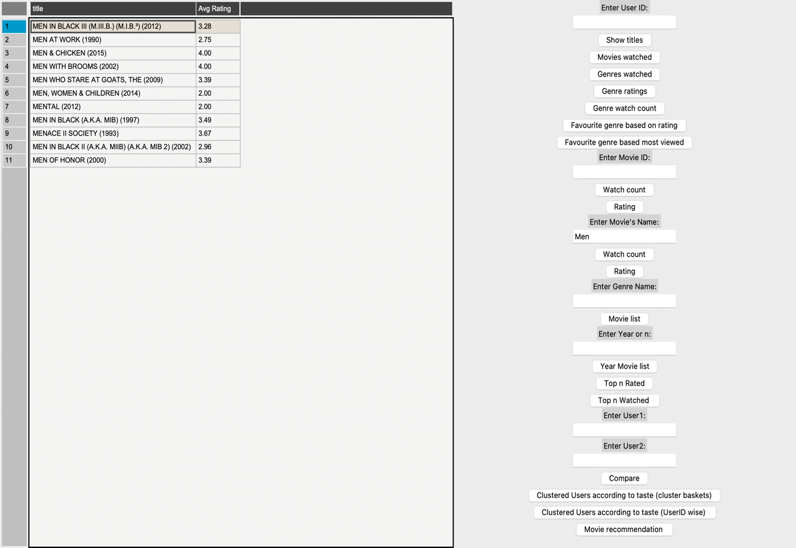

Figure movie name rating

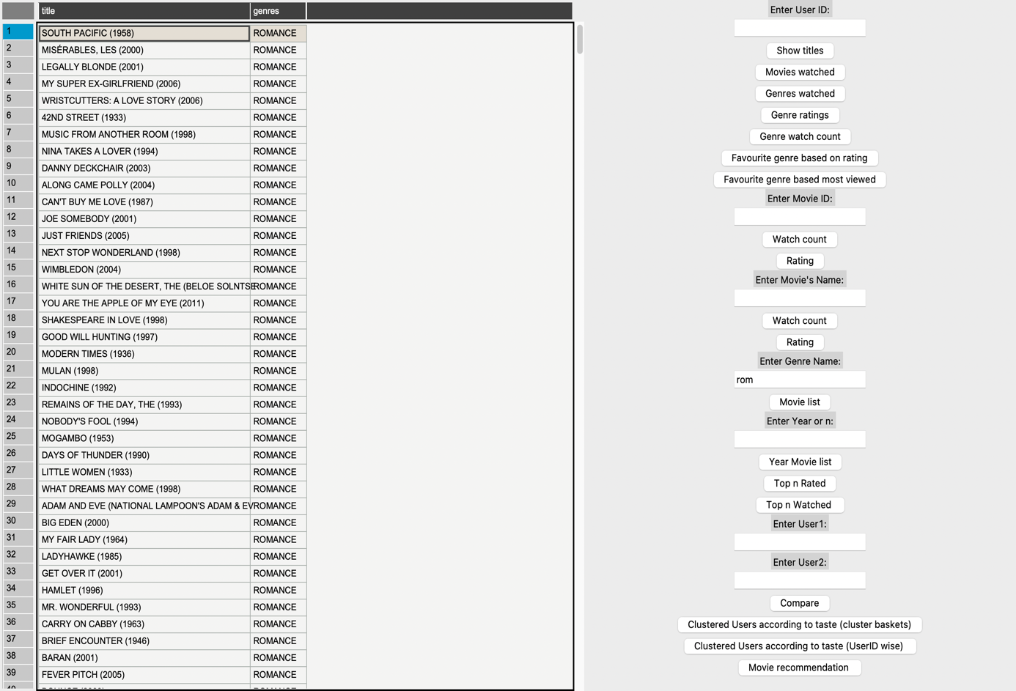

Figure genre movie list search

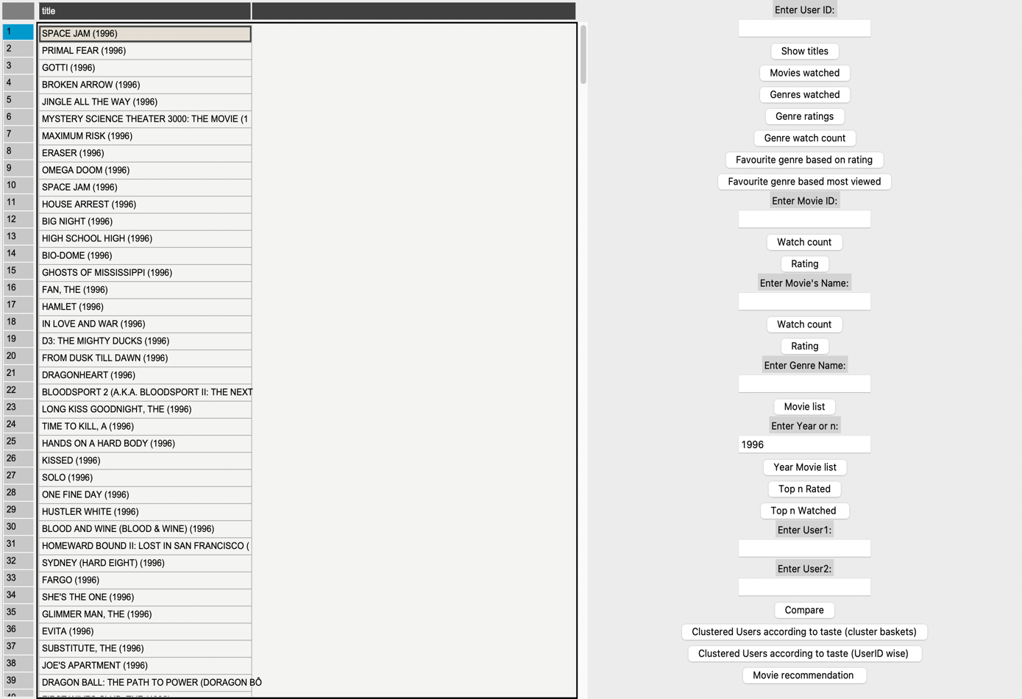

Figure year wise movie search

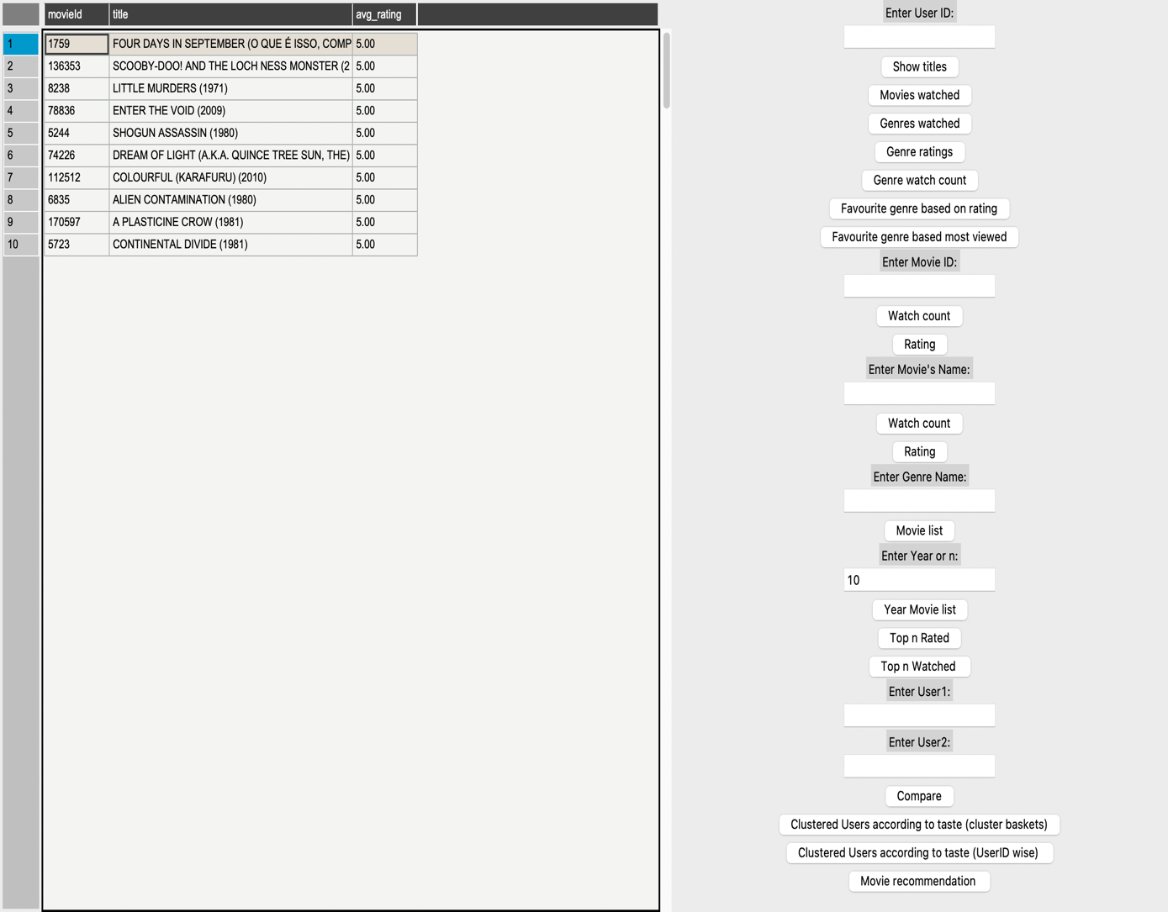

Figure Top n rated

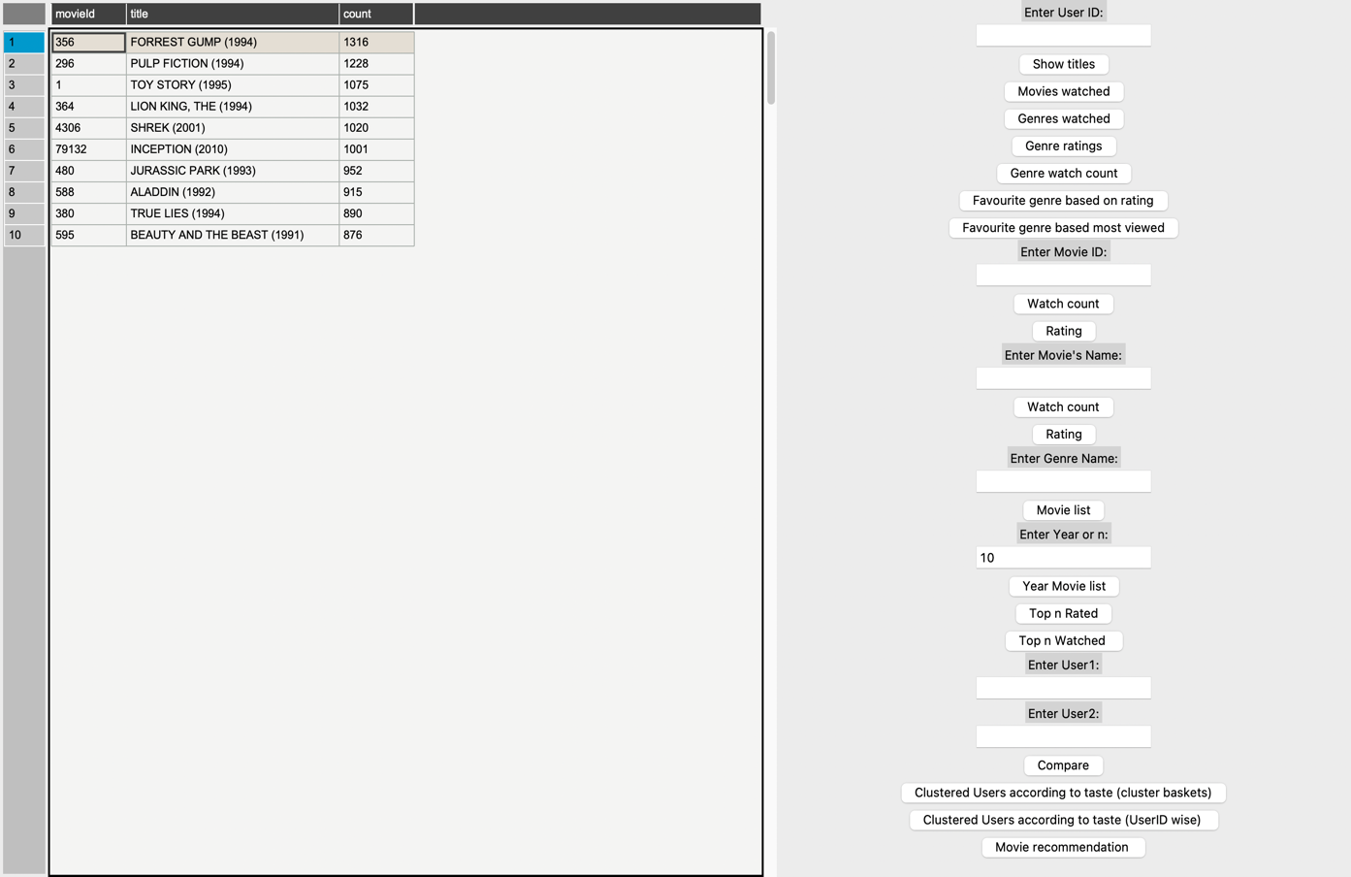

Figure top n watched

# Summary Part 2:

For this part, I implemented the Favourite genre based on ratings and Favourite genre based on most watched, by user Id (6 and 7 buttons in part 1).

I added the functionality to compare the taste of 2 users based on the genre ratings and number of movies watched from each genre.

Finally for part 2, I implemented K means clustering algorithm for clustering users according to their taste. To this end, taste is defined by the number of movies watched by the user from each genre. I decided on using the genre most watched by the user because of the abnormality of different genres available. For Example, Film Noir genre isn’t a genre that has many movies, if a user has watched only one movie and liked it with a high rating, it would not reflect his real preference. I have added 2 buttons for viewing this:

* 1. Cluster basket view: which puts the user in cluster baskets or columns of their assigned cluster.
  2. User Id view: that shows the user Id wise view of cluster.

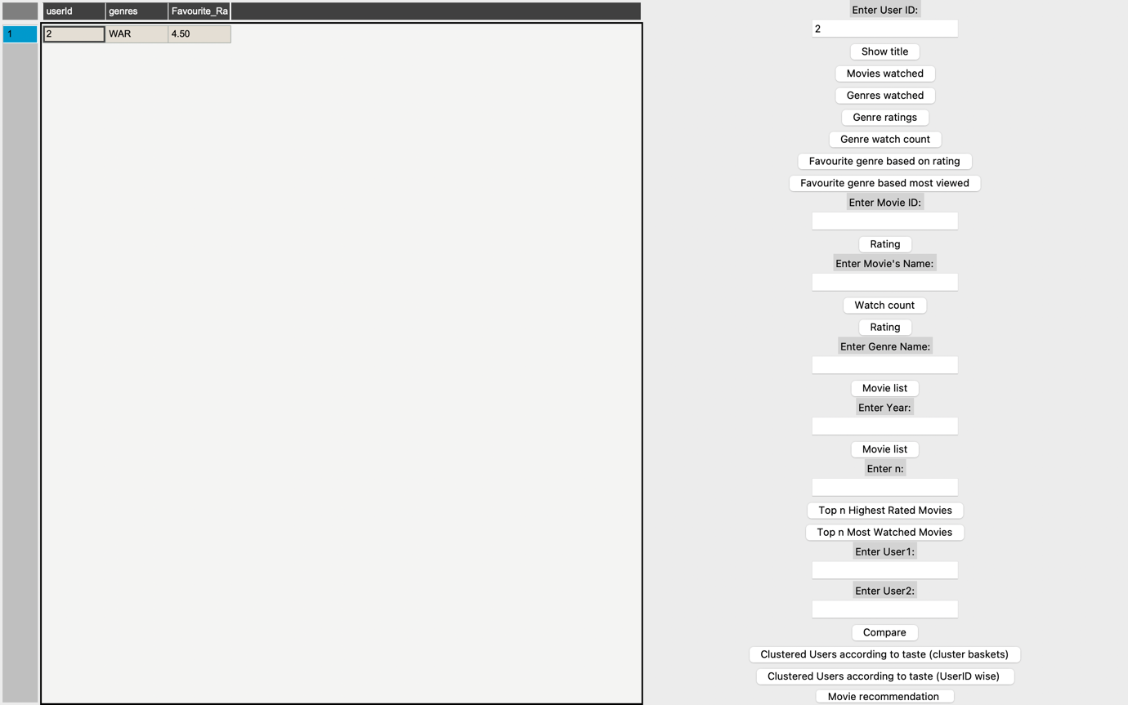

Figure 14 favourite genre (rating based)

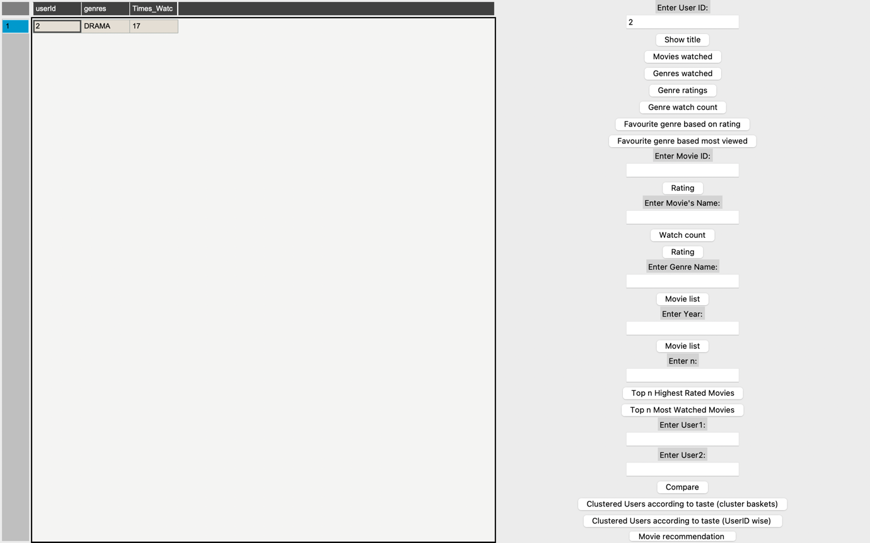

Figure 15 favourite genre (most viewed)

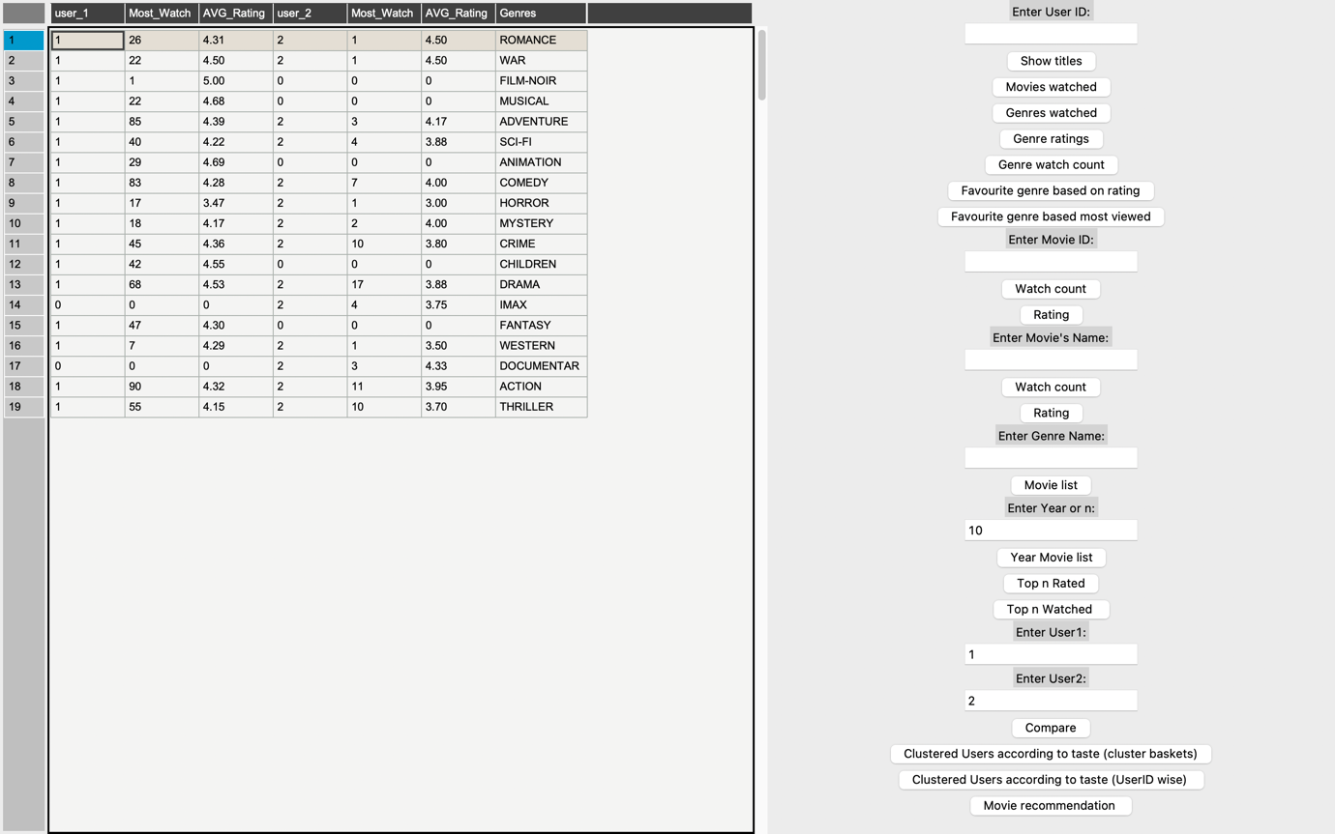

Figure 16 user comparison

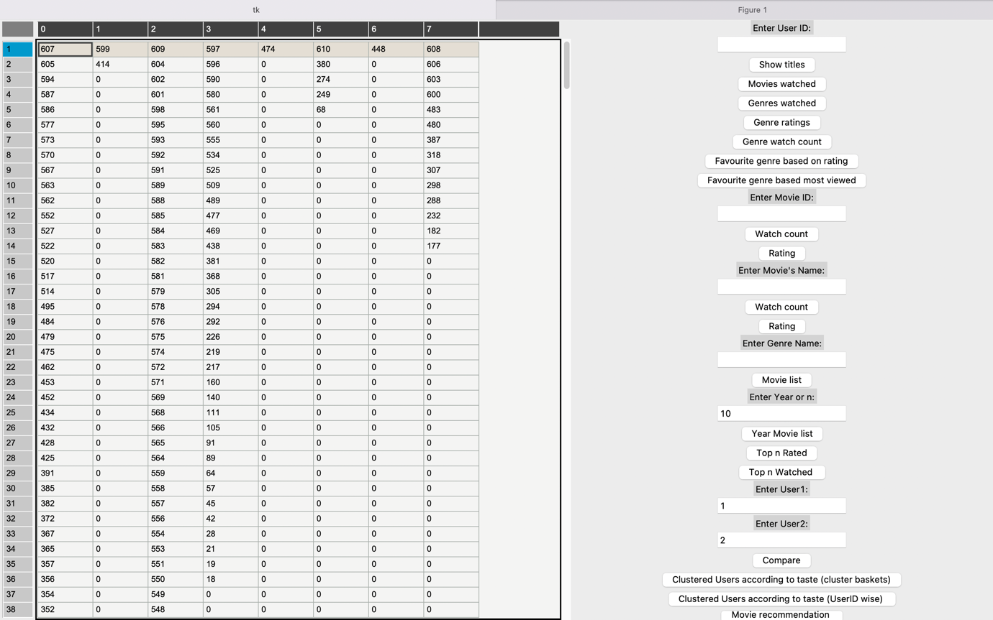

Figure 17 cluster basket view

# Summary part 3:

For this part I have implemented the whole application with Pandas table, this gives a nice view of all the data. The other option was printing, which was untidy and difficult to interpret.

For the User cluster, I have provided the cluster assignment graph, this was done using ﻿ml.feature was used, function ‘PCA’.

Lastly, I have added a movie recommendation system, which uses the rating given by the user to predict his preferences. To this end, ﻿pyspark’s ml.recommendation was used with its function ‘ALS’.

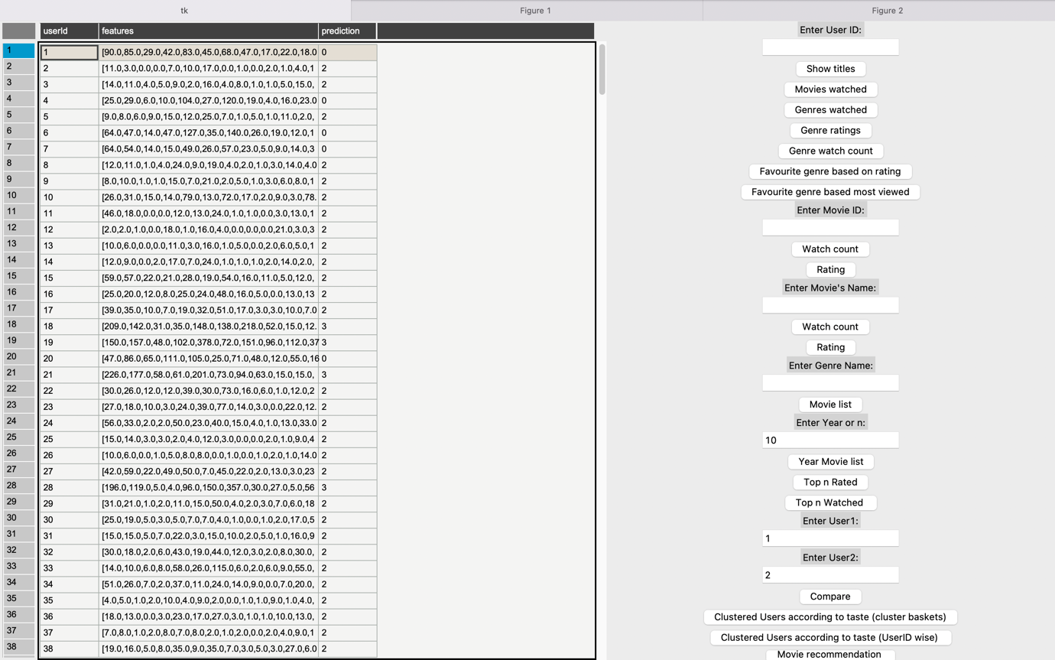

Figure 18 movie recommendation system

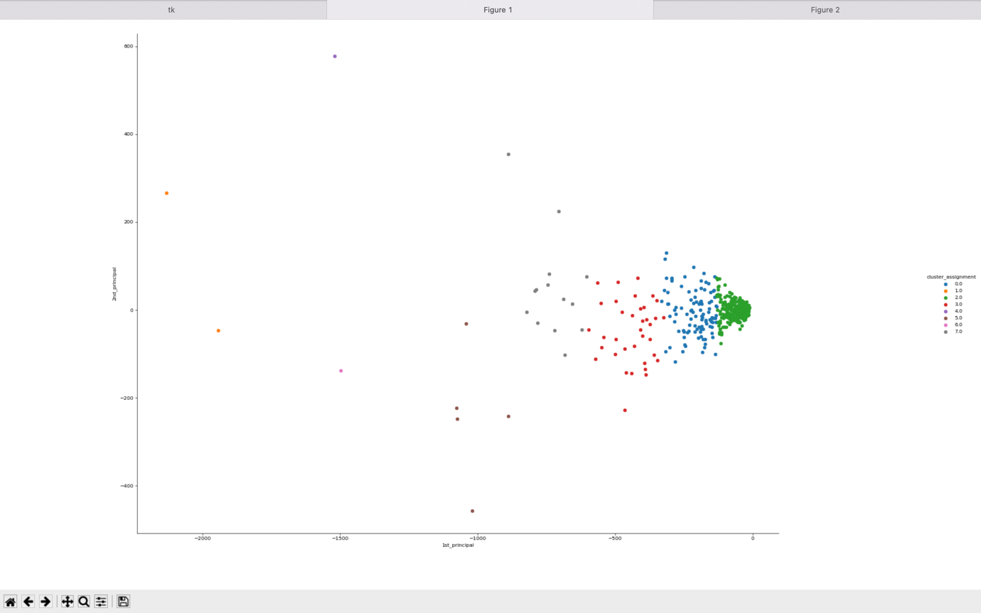

Figure 19 cluster graph visualization

# Other effort:

I also implemented this program on a console, using spark submit. It was a fine application having a limitation that you can’t have visualizations loaded onto it. I used a command that takes input in runtime, not possible with python’s input command. But as mentioned before, the lack of visualizations forced me to switch to an application.

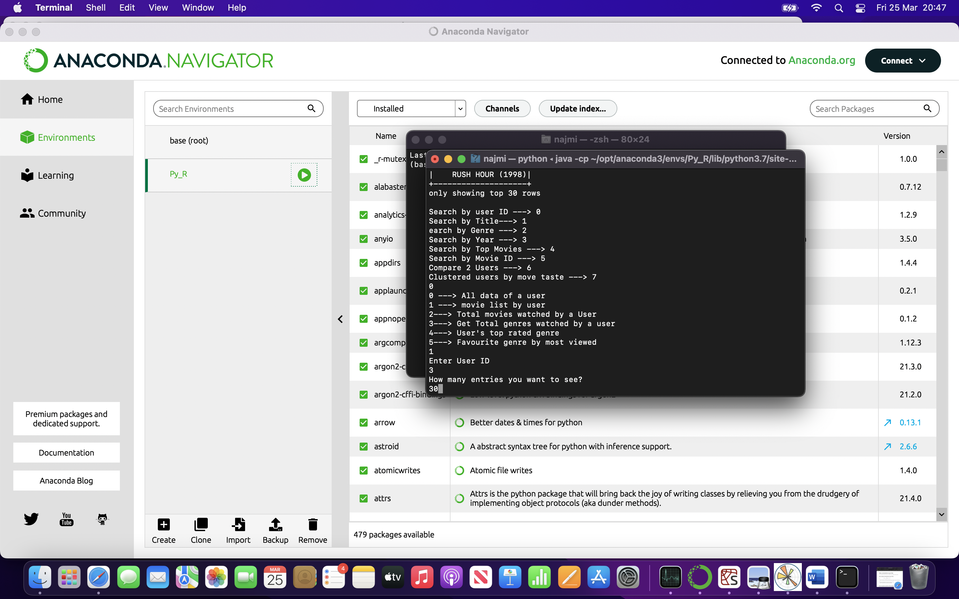

Figure console app interface

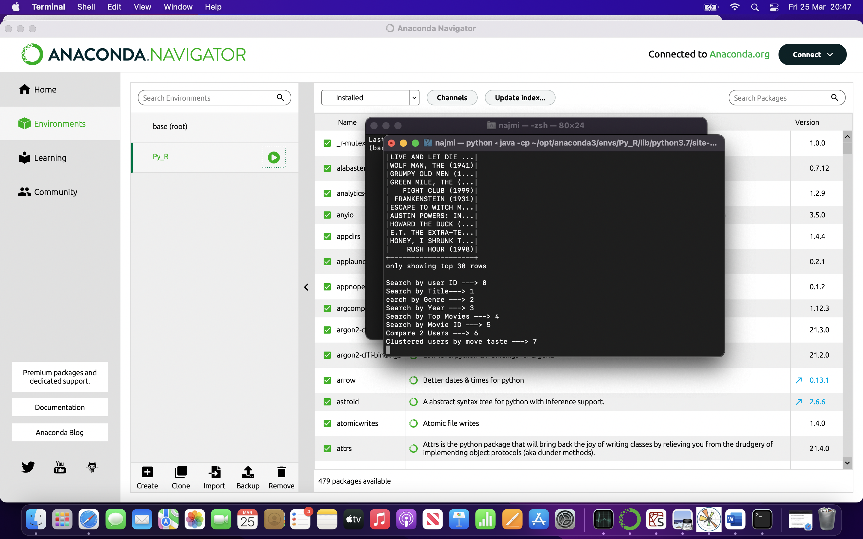

Figure some result